DIS-PAC-POLY-Fiji-Gata Club

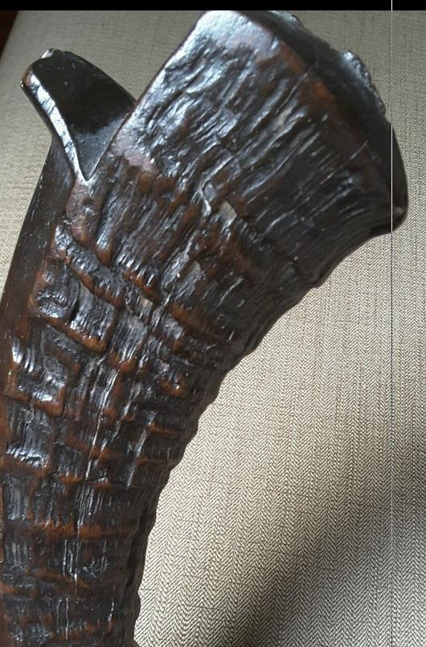

# Fijian Ngata or Sali Type Wooden Carved War Club